Smart Pantry
A Pantry-Aware Meal Recommendation System for Food Waste Reduction
Patrice Jones
Full Sail University
Software Project: Development II - COS670
Second Thesis Draft
July 2026

Abstract
Household food waste is often connected to poor pantry visibility, forgotten ingredients, duplicate purchases, and difficulty deciding what to cook with food already available. Smart Pantry was developed as a web-based pantry management and meal recommendation platform that connects household inventory with practical, explainable meal suggestions. The current research platform includes a neutral Wix study website, Google Forms, a manual Pantry Notes Tracker, Samsung Food as an outside Ingredient Recipe Finder, the Smart Pantry application, and an administrator dashboard. The application uses a React frontend, FastAPI backend, Supabase/PostgreSQL database, cloud deployment through Vercel and Render, a cleaned recipe dataset, UPC and food-data services, transparent Smart Score logic, and a Random Forest support model for Nutrition Fit. Participants complete the same three activities and provide feedback after each one, allowing manual tracking, a commercial recipe-finder, and a pantry-first recommendation system to be compared within one study. Quantitative data will be summarized with descriptive statistics, while matching pre-study and post-study items will be evaluated with a paired-samples t-test when assumptions are met and the Wilcoxon signed-rank test when they are not. Open-ended responses and application records will provide additional evidence about usability, recommendation usefulness, pantry awareness, and ingredient use. The project contributes a working full-stack application, an explainable pantry-aware recommendation process, and a repeatable participant-study workflow for evaluating household food-management technology.

Keywords: food waste, pantry management, meal recommendation systems, Smart Pantry, Nutrition Fit, Smart Swaps, human-computer interaction, machine learning

Table of Contents

1. Introduction
Household food waste remains a practical problem even though recipes, shopping lists, and meal-planning tools are widely available. Food can still be forgotten in the pantry, refrigerator, or freezer, purchased more than once, or discarded because no clear meal plan was connected to the available ingredients. USDA estimates indicate that food loss and waste represent approximately 30 to 40 percent of the United States food supply [1]. At the household level, the issue is often less about access to recipes and more about knowing what is available, what should be used first, and what can realistically be prepared.
Existing food applications support useful tasks such as recipe search, weekly meal planning, grocery lists, and ingredient tracking. However, those features are often separated. A pantry list may show inventory but provide no meal guidance. A recipe application may provide thousands of choices without knowing what is already in the home or which item is nearing expiration. Smart Pantry was developed to bring those decisions together in one platform.
The proposed system combines pantry inventory, expiration awareness, participant preferences, meal recommendations, Smart Swaps, recommendation history, and administrative study evidence. It is supported by a separate Pantry & Meal Planning Study website so the research process remains clear and neutral. Participants compare three approaches: a manual Pantry Notes Tracker, Samsung Food as an Ingredient Recipe Finder, and the Smart Pantry Recommendation Tool.

1.1 Problem Definition
Current pantry-management methods do not always help households move from knowing what food is present to deciding how that food should be used. Manual notes and spreadsheets can record inventory, but they require regular updates and offer no automatic meal support. Commercial recipe applications may provide strong search and planning tools, yet their main focus is often recipe discovery rather than expiration priority, realistic pantry coverage, or measurable ingredient use.
Recommendation quality creates another challenge. A recipe may appear to match a pantry while still requiring missing ingredients, unrealistic quantities, or substitutions that do not preserve the role of the original ingredient. Limited explanation can also make it difficult to understand why one meal was ranked above another. The problem addressed in this thesis is therefore the lack of a focused, explainable, pantry-first workflow that connects inventory, expiration information, recommendations, substitutions, and participant evidence within one system.

1.2 Research Question
The primary research question is:
Does Smart Pantry improve pantry awareness, recommendation usefulness, and ingredient utilization compared with manual pantry tracking and an existing ingredient-based recipe application?
Supporting questions examine whether the application helps participants understand available inventory, whether the recommendations feel useful and realistic, whether confidence in meal planning changes, and how the three methods compare in overall usability and preference.

1.3 Hypothesis
Participants using Smart Pantry are expected to report stronger pantry awareness, greater meal-planning confidence, and higher perceived recommendation usefulness than they report for the manual Pantry Notes Tracker and Samsung Food comparison activity. Smart Pantry is also expected to receive stronger ratings for expiration support and explanation, while Samsung Food may receive stronger ratings for recipe variety and commercial polish.

1.4 Motivation and Interested Users
The motivation behind the project comes from a common household experience: food is available, but deciding what to cook still feels difficult. Ingredients may be spread across several storage locations, quantities may be unclear, and items may be forgotten until they are close to expiration. A pantry-aware system can reduce that gap by turning inventory into practical meal evidence instead of leaving the participant to search through unrelated recipes.
The intended users include adults who purchase groceries, prepare meals, or help manage food within a household. The project is also relevant to software engineers and researchers working in recommendation systems, human-computer interaction, food-waste reduction, machine learning, and user-centered application design.

1.5 Contributions and Significance
The project contributes in three connected areas. The software engineering contribution is a deployed full-stack application built with React, FastAPI, Supabase, Vercel, and Render. The recommendation contribution is a pantry-first scoring process that combines Pantry Match, Coverage, expiration priority, profile fit, Smart Swaps, and machine learning-based Nutrition Fit. The research contribution is a structured participant workflow that brings together a neutral study website, three comparison activities, feedback forms, application records, an administrator dashboard, and exportable evidence.
The significance of the work is not based on replacing every commercial cooking application. The value comes from examining whether a focused pantry-aware system can help participants understand available food and make more intentional meal decisions. The platform also provides a foundation for future studies involving household food management and recommendation technology.

2. Background

2.1 Current Understanding of Household Food Waste
Food waste has economic, social, and environmental effects. USDA identifies food loss and waste as a major issue within the food supply [1], while the EPA emphasizes prevention and source reduction before disposal [2]. At home, waste can begin when food is hidden from view, purchased without checking existing inventory, or left unused because the household does not have a practical plan for it.
Improved awareness is only one part of the solution. A person may know that eggs, vegetables, or canned goods are present and still not know how to combine them into a meal. This supports a design approach that connects inventory records to decision support rather than treating pantry tracking and recipe search as separate activities.

2.2 Pantry Management and Meal-Planning Approaches
Manual pantry management includes memory, paper notes, phone notes, and spreadsheets. These methods are inexpensive and familiar, but their accuracy depends on regular updates. As the number of items grows, the list becomes harder to maintain, and the method provides no automatic connection between inventory and meals.
Digital systems improve organization by storing lists, recipes, and plans across devices. Ingredient-based recipe finders reduce search effort by allowing users to begin with food they already have. Even so, the usefulness of those systems depends on the quality of the ingredient match, the handling of quantities and missing ingredients, and the clarity of the recommendation.

2.3 Existing Solutions and Similar Applications
Samsung Food supports recipe organization, meal planning, shopping lists, ingredient search, and access across web and mobile devices [3]. Its recipe ecosystem and polished interface make it a useful comparison for participant experience. For this study, the free version is used as an Ingredient Recipe Finder. The comparison focuses on recipe discovery and ease of use rather than paid pantry features.
SuperCook uses an ingredient-first recipe-search approach. Users identify available ingredients, and the platform returns recipes that can be prepared from those selections [4]. This approach demonstrates the value of beginning with pantry contents, but its primary focus is recipe discovery rather than persistent quantity tracking, expiration priority, recommendation evidence, and research metrics.
Academic systems also support the connection between food inventory and recipe recommendation. Ortiz et al. developed an IoT-based food inventory and recipe recommendation system for perishable items [5]. RecipeIS examined recipe recommendation from recognized ingredients [6], while Chhipa et al. applied TF-IDF to recipe recommendation [7]. These studies support ingredient matching as a reasonable technical foundation, but household meal decisions may also depend on quantities, allergies, expiration, substitutions, and explanation.

2.4 Barriers in Current Solutions
Manual entry remains a barrier because accurate pantry records require effort. Barcode, receipt, OCR, and CSV options can reduce repeated typing, but the information still needs to be reviewed before saving. Recommendation quality is another barrier. Ingredient overlap alone can produce meals that are incomplete, repetitive, or unrealistic. Trust also matters. Explainable recommendation research suggests that users benefit when the reason behind a result is visible [8], [9].
The reviewed applications and studies each address useful parts of the problem, but few combine persistent pantry inventory, expiration priority, realistic substitutions, visible recommendation evidence, participant activity records, and administrative study exports within one workflow. This gap provides the basis for Smart Pantry.

2.5 Research Gap
The research gap is the limited integration of pantry management, explainable recommendation logic, and structured participant evaluation. Commercial applications generally serve consumer cooking and planning needs, while academic studies frequently focus on algorithm performance or individual features. Fewer systems provide a complete research environment that includes participant instructions, comparison activities, feedback, application logs, and administrator review.
Smart Pantry addresses this gap by combining a neutral study portal with a custom pantry application. The system does not attempt to compete with the scale of a commercial recipe platform. Instead, it evaluates whether a transparent pantry-first workflow can improve awareness, meal support, and intentional ingredient use.
Table 1. Comparison of Pantry Management Approaches
Feature | Manual Pantry Tracker | Samsung Food (Free) | Smart Pantry
Persistent inventory | Manual | Available | Available
Quantity and unit tracking | Manual | Limited / interface-dependent | Available
Expiration emphasis | Manual | Limited in free comparison activity | Available with alerts
Ingredient-based recipe discovery | No | Available | Available
Pantry Match and Coverage evidence | No | Limited | Available
Machine learning-based Nutrition Fit | No | Not part of comparison activity | Available
Suggested and custom Smart Swaps | No | Not part of comparison activity | Available
Recommendation History | No | Consumer history features | Study action history
Participant study workflow | No | No | Available
Admin research dashboard and export | No | No | Available

3. Methodology

3.1 Research Design
The study uses a within-subject mixed-methods design. Each participant completes the same three activities in the same order, allowing the manual tracker, Samsung Food, and Smart Pantry to be compared within one participant group. Quantitative evidence comes from surveys, rating-scale feedback, and application records. Open-ended responses provide additional context about usability, confusion, strengths, and suggested improvements.

3.2 Participants and Recruitment
Participants must be at least 18 years old and regularly purchase groceries, prepare meals, or help manage food within their household. Recruitment will be conducted through public online outreach, university-related channels, community groups, and social media. Participation is voluntary, and all participants will review the informed consent form before beginning the study. No participant is required to purchase a subscription or pay to use any study tool.
The full evaluation is designed for a minimum of 30 participants. A pilot test has already been completed with a small group. The pilot confirmed the basic study flow and identified areas that needed improvement, including clearer instructions, mobile resizing, recommendation loading messages, login support, survey separation, and the Smart Swap experience.
A unique participant ID or study username is used across the surveys and application. This identifier connects records while limiting the amount of unnecessary personal information collected.

3.3 Study Procedure
The Pantry & Meal Planning Study website serves as the main participant guide. It provides the study protocol, consent information, survey links, activity instructions, and completion steps. Participants are asked to use the same general pantry items across the three activities when possible so the comparison remains consistent.
- Review the study protocol and informed consent.
- Complete the pre-study survey.
- Complete Activity 1, the Pantry Notes Tracker, followed by the matching feedback form.
- Complete Activity 2, Samsung Food as the Ingredient Recipe Finder, followed by the matching feedback form.
- Complete Activity 3, the Smart Pantry Recommendation Tool, followed by the matching feedback form.
- Complete the post-study survey and study-completion step.

3.4 Study Activities
Activity 1 represents a manual baseline. Participants enter pantry, refrigerator, and freezer items into a spreadsheet-style web tracker that does not generate recommendations. Activity 2 represents an established consumer recipe-finder. Participants use Samsung Food to search for meal ideas from selected ingredients, and only feedback about the experience is collected. Activity 3 represents the proposed pantry-first system. Participants manage inventory, review expiration information, generate recommendations, inspect recommendation evidence, and interact with Smart Swaps and Recommendation History.

3.5 Data Collection
The pre-study survey records current habits, awareness, and confidence before the activities begin. Each feedback form measures ease of use, usefulness, meal support, confusion, and missing features. The post-study survey asks participants to compare the three methods and explain their final preference.
Smart Pantry records pantry items, quantities, expiration dates, recommendations, recommendation actions, Smart Swaps, participant comments, and ingredient-use evidence. Google Forms responses and application exports are linked through the participant ID.

3.6 Statistical Analysis
Descriptive statistics will be calculated first, including response counts, means, medians, standard deviations, frequencies, and percentages. Matching pre-study and post-study items will be evaluated with a paired-samples t-test because the same participants complete both surveys. Statistical significance will be evaluated at α = 0.05.
The distribution of the difference scores will be reviewed before applying the t-test. If the normality assumption is not reasonably met, the Wilcoxon signed-rank test will be used as the non-parametric alternative. Open-ended comments will be grouped into themes such as ease of use, recipe variety, pantry awareness, expiration support, recommendation clarity, mobile usability, and suggested improvements.

3.7 Verification and Validation
Verification confirms that technical features perform as designed. Validation focuses on whether participants understand the workflow and find the system useful. The pilot supported both goals by exposing technical errors and participant-facing confusion before the full study.
Table 2. Verification and Validation Criteria
Feature | Verification | Validation
Login and account separation | Valid users authenticate and retain separate records | Participants can log in and cannot view another participant's data
Pantry Notes Tracker | Rows save and reload under the correct account | Participants can complete the manual activity without recommendations
Pantry management | Items, units, quantities, and dates save correctly | Participants can review and correct inventory
Recommendations | Cards load from pantry and profile data | Participants judge suggestions as relevant and understandable
Pantry Match and Coverage | Values reflect recipe requirements and available ingredients | Participants understand what can be made and what is missing
Nutrition Fit | Model output is generated and displayed | Participants understand the participant-facing label
Smart Swaps | Suggested and custom swaps save correctly | Participants find substitutions useful or can reject them
Admin dashboard | Metrics and exports populate correctly | Study evidence can be reviewed without direct database queries
Study website and forms | Buttons open the intended activity or form | Participants can follow the sequence with limited assistance

4. Presentation of Work (Progress to Date)
The current work demonstrates that the project has moved beyond an early prototype. The study website, survey structure, manual comparison activity, Smart Pantry application, recommendation engine, participant history, and administrator tools are functioning as a connected research workflow. The present section summarizes the completed system and the corrections made after advisor and pilot feedback.

4.1 Research and Study Website
A neutral Pantry & Meal Planning Study website was created in Wix to separate the official study instructions from the Smart Pantry application. The site includes the study protocol, pre-study survey, activity page, post-study survey, help information, and study-completion steps. Google Forms are used for the official surveys and activity feedback so participant responses remain organized outside the proposed application.
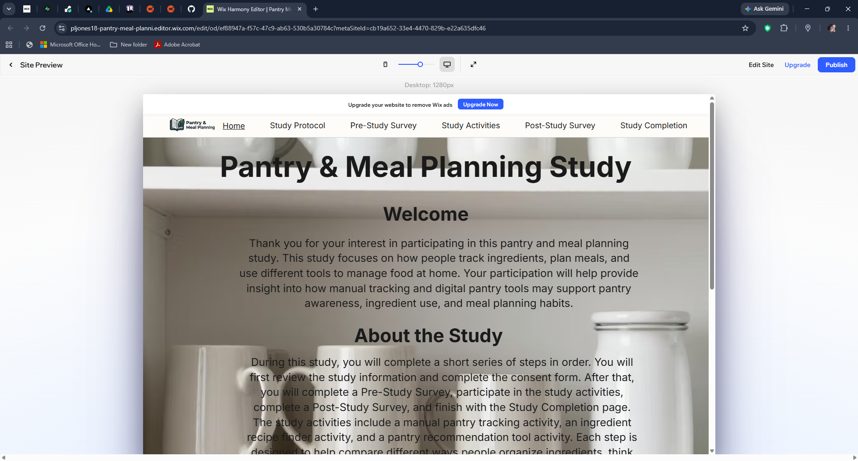
Figure 1. Pantry & Meal Planning Study website.

4.2 Pantry Notes Tracker
The Pantry Notes Tracker was developed as the manual baseline activity. It uses a simple spreadsheet-style interface and does not provide recommendations, Nutrition Fit, Smart Score, or Smart Swaps. Participant records are saved under the assigned account and can be reviewed through the administrator dashboard.
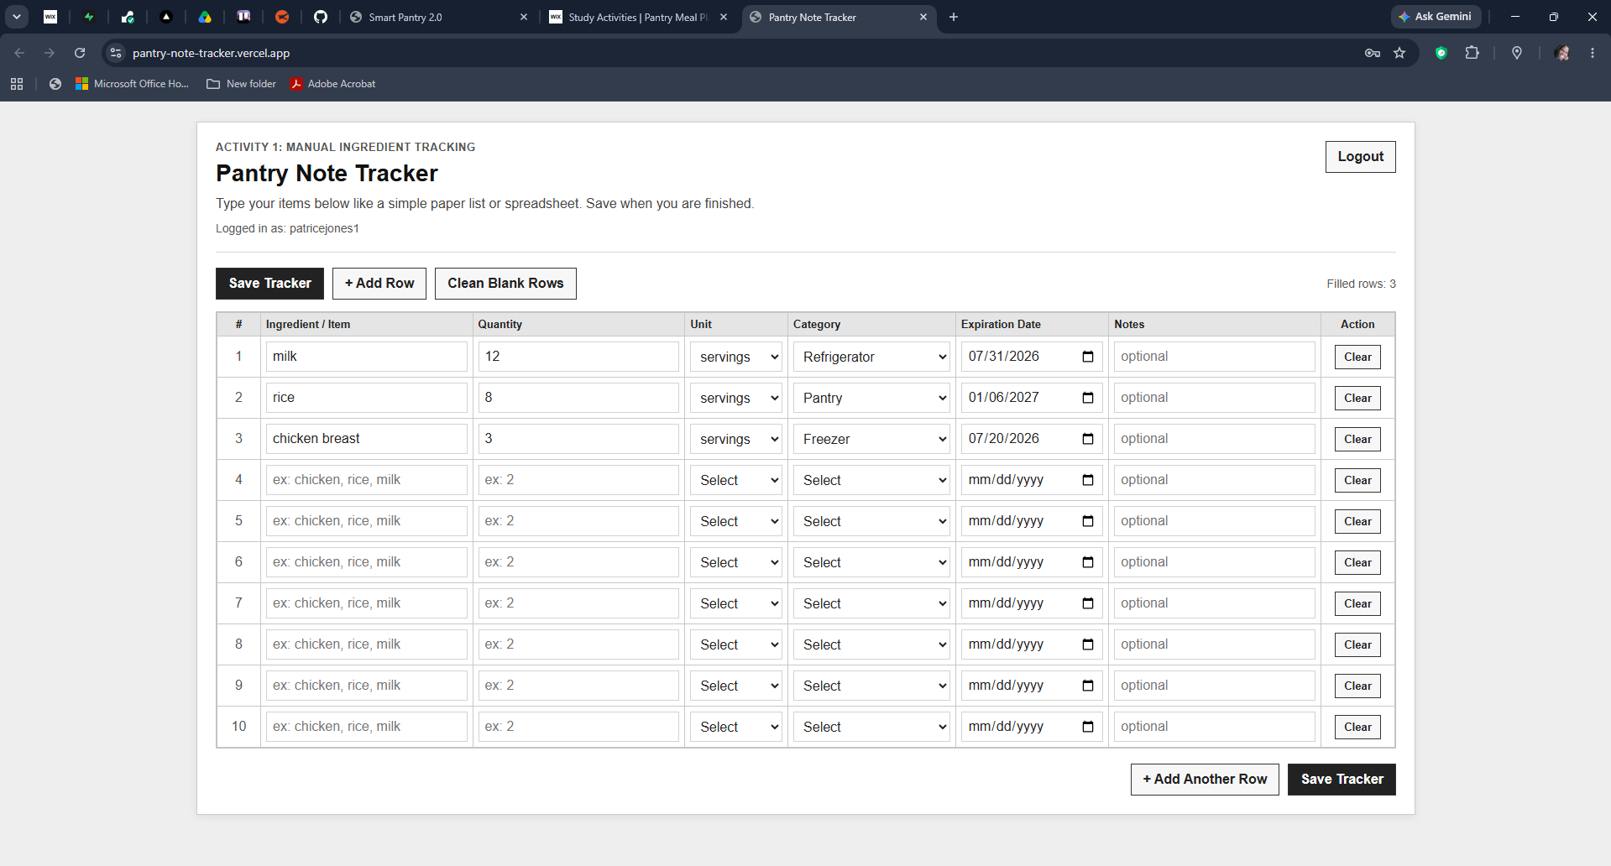
Figure 2. Activity 1 Pantry Notes Tracker.

4.3 Smart Pantry Application
Smart Pantry 2.0 uses a React frontend, FastAPI backend, and Supabase/PostgreSQL database. Vercel hosts the participant-facing frontend, and Render hosts the backend API. Participant authentication, pantry records, recommendation actions, and related research evidence are stored in Supabase.
The participant dashboard summarizes pantry totals, expiration attention, category distribution, grocery suggestions, and the recommended next action. The pantry page supports item name, category, quantity, unit, container type, expiration date, brand, barcode, and notes. UPC lookup, receipt-assisted entry, OCR-supported entry, and CSV import reduce repeated manual entry while allowing the participant to review information before saving.
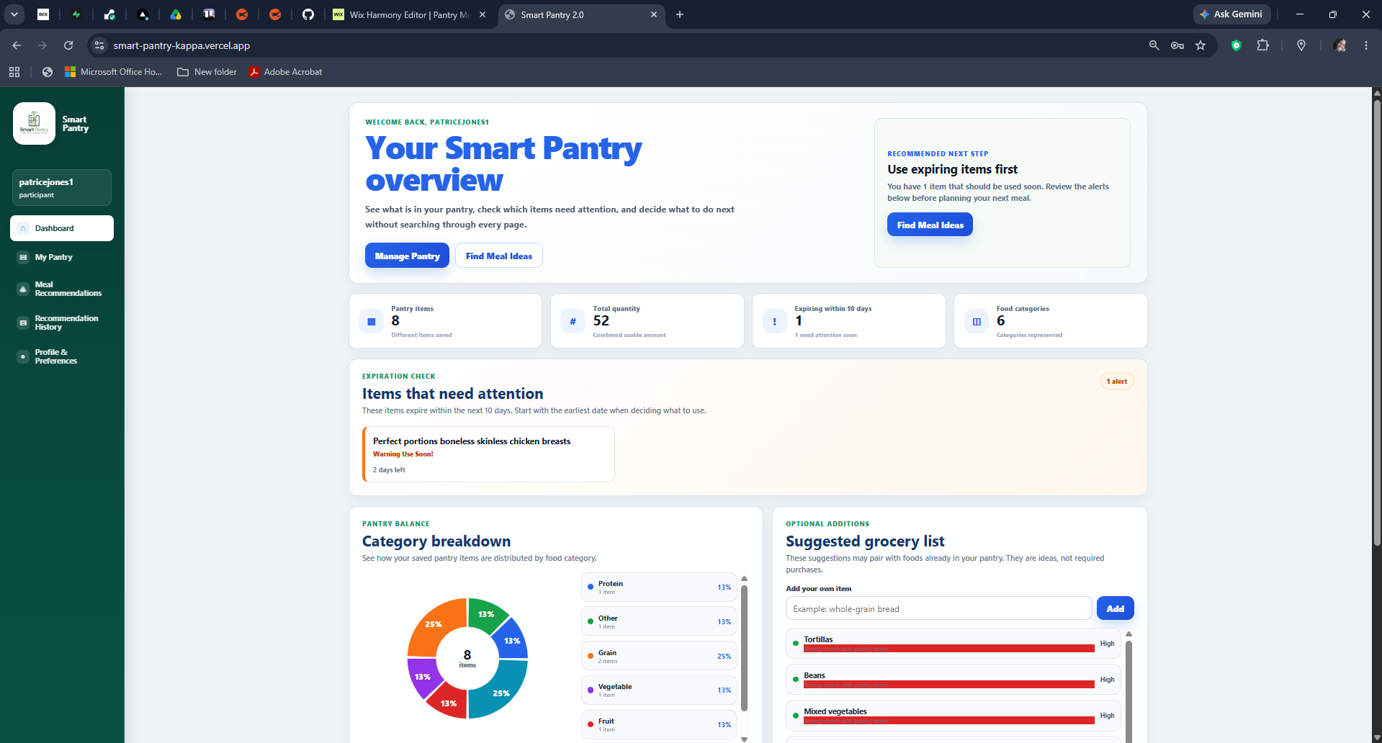
Figure 3. Smart Pantry participant dashboard.
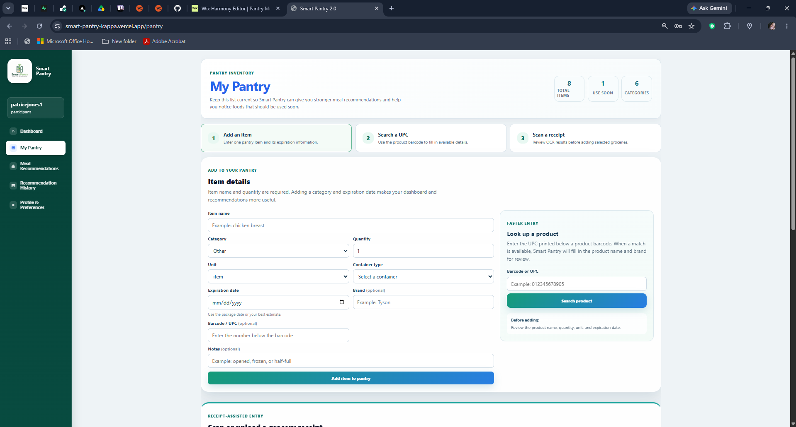
Figure 4. Smart Pantry pantry-management interface.

4.4 Recommendation Engine and Machine Learning Support
The recommendation engine begins with the participant's saved pantry and profile. Ingredient names are normalized, allergy and avoid-food rules are applied, and candidate recipes are evaluated using Pantry Match, Coverage, expiration priority, profile fit, missing-ingredient penalties, and duplicate-recipe controls. The highest-ranked results are displayed through filter categories such as Pantry Match, Almost There, Expiring First, Quick Everyday, and Expanded Library.
Nutrition Fit is the Random Forest machine learning component. It contributes a nutrition-based score but does not replace the transparent pantry factors. Recommendation cards show the score and evidence in participant-friendly language so the result can be understood without requiring technical knowledge of the model.
Smart Swaps are presented as suggestions instead of guaranteed equivalents. Approved substitutions can be selected when available, and participants may add a custom swap based on their own cooking decision. The selected swap and participant feedback are saved as research evidence.
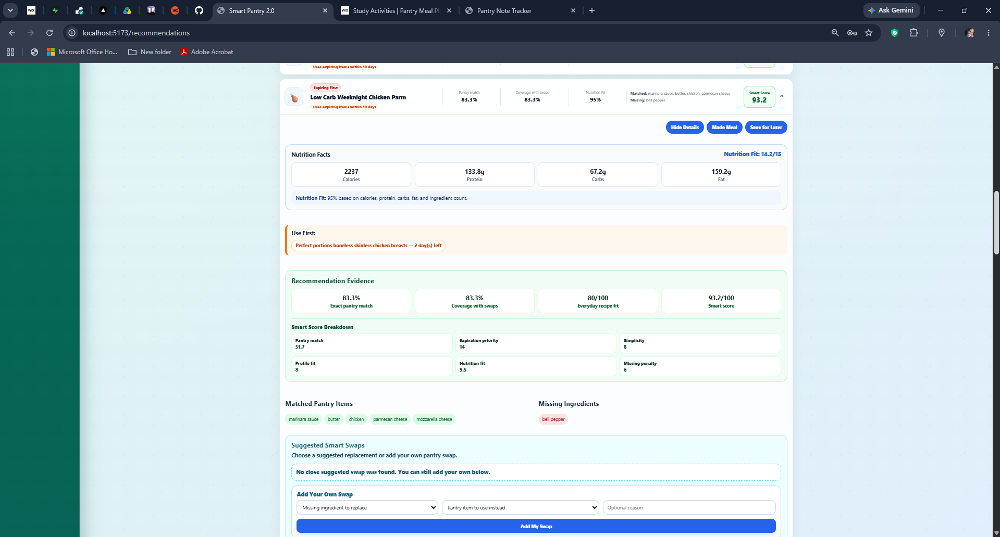
Figure 5. Expanded recommendation card showing Pantry Match, Coverage, Nutrition Fit, Smart Score, and recommendation evidence.

4.5 Recommendation History and Administrator Evidence
Recommendation History stores participant decisions such as Made Meal, Used Elsewhere, Saved for Later, and Did Not Use. These actions provide a record of how recommendations were handled rather than recording only that a card was displayed.
The administrator dashboard summarizes participant totals, pantry activity, Activity 1 records, recommendation actions, acceptance information, study evidence, and downloadable CSV exports. Official survey responses are collected through Google Forms, while the application dashboard focuses on Smart Pantry and tracker evidence. The two data sources will be connected through the participant ID during analysis.
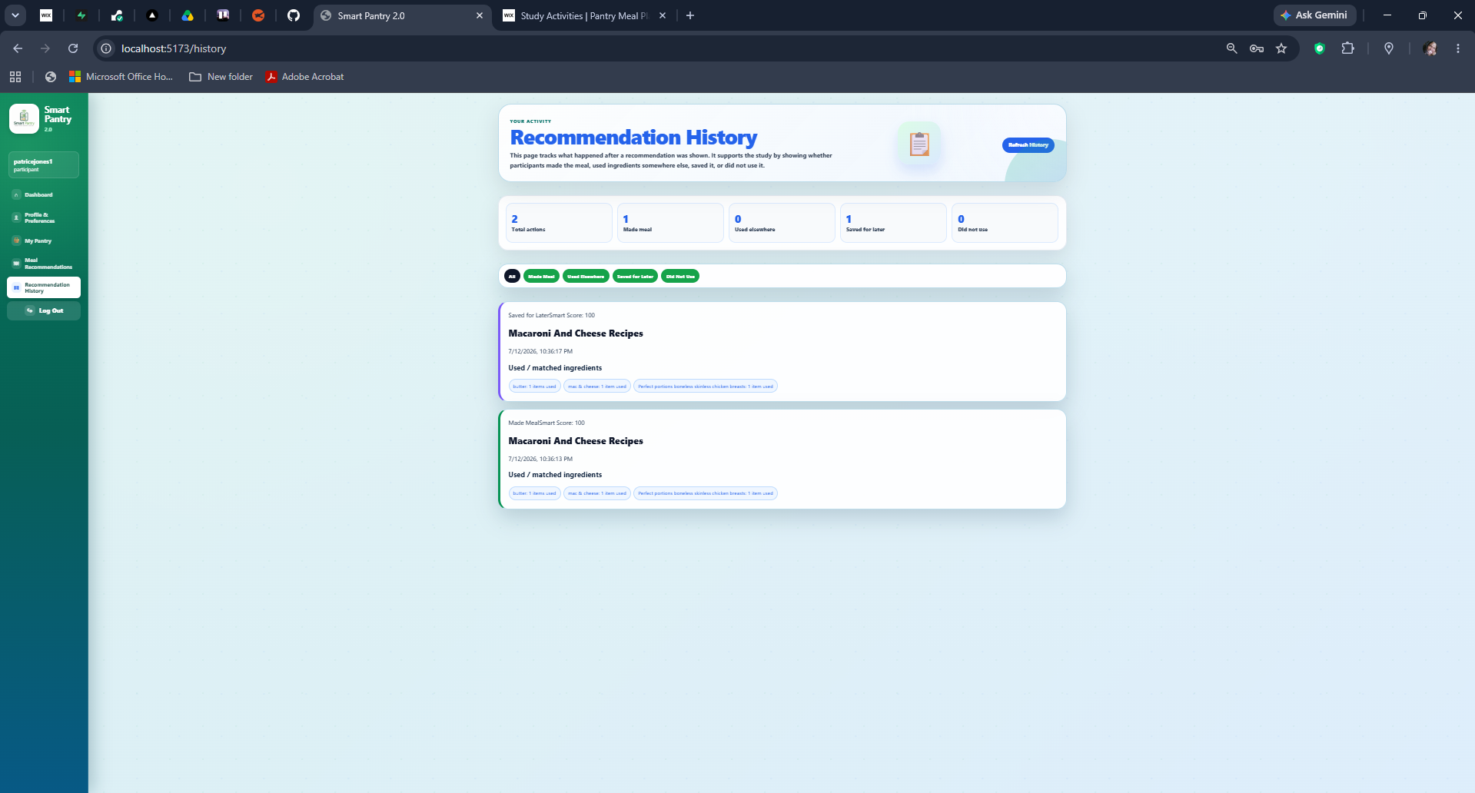
Figure 6. Smart Pantry Recommendation History.
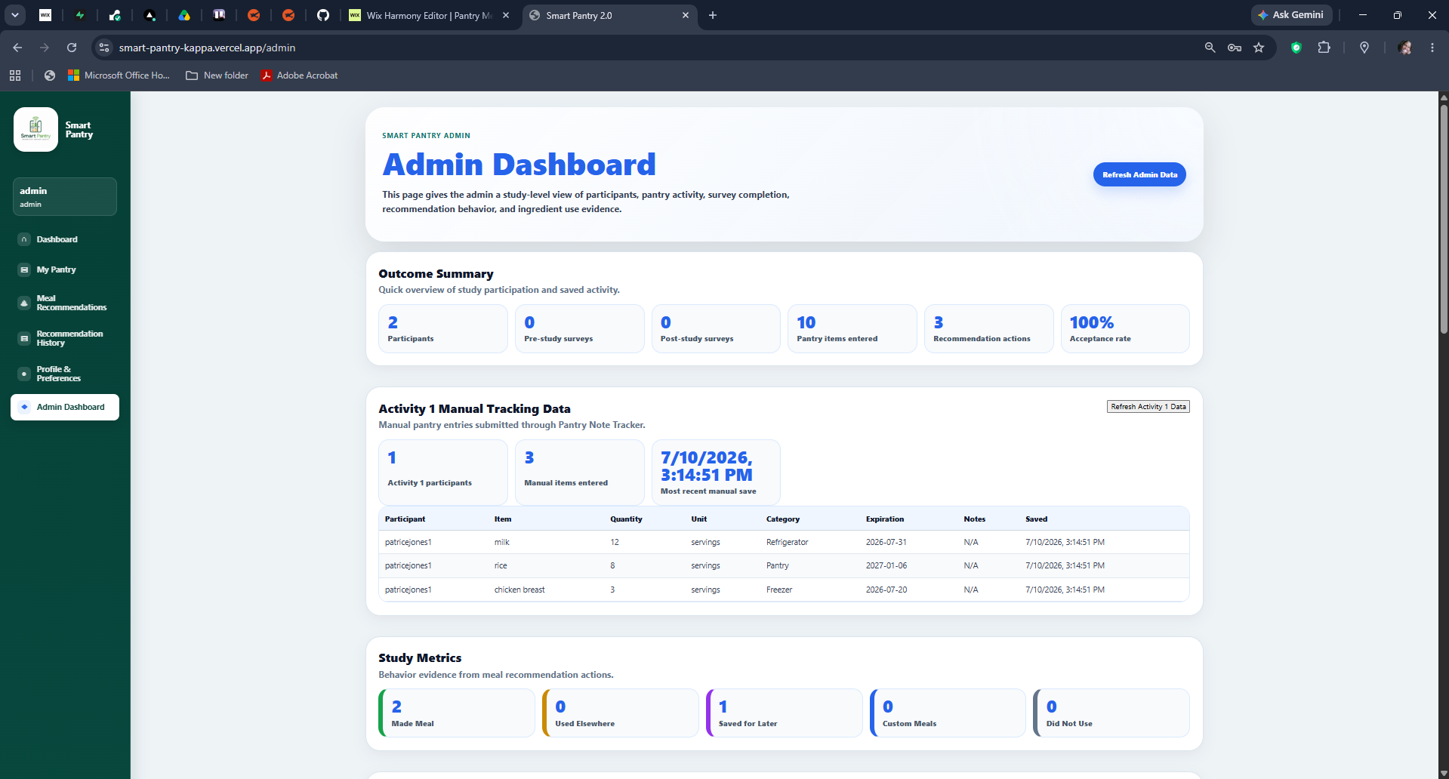
Figure 7. Administrator dashboard showing participant and Activity 1 metrics.
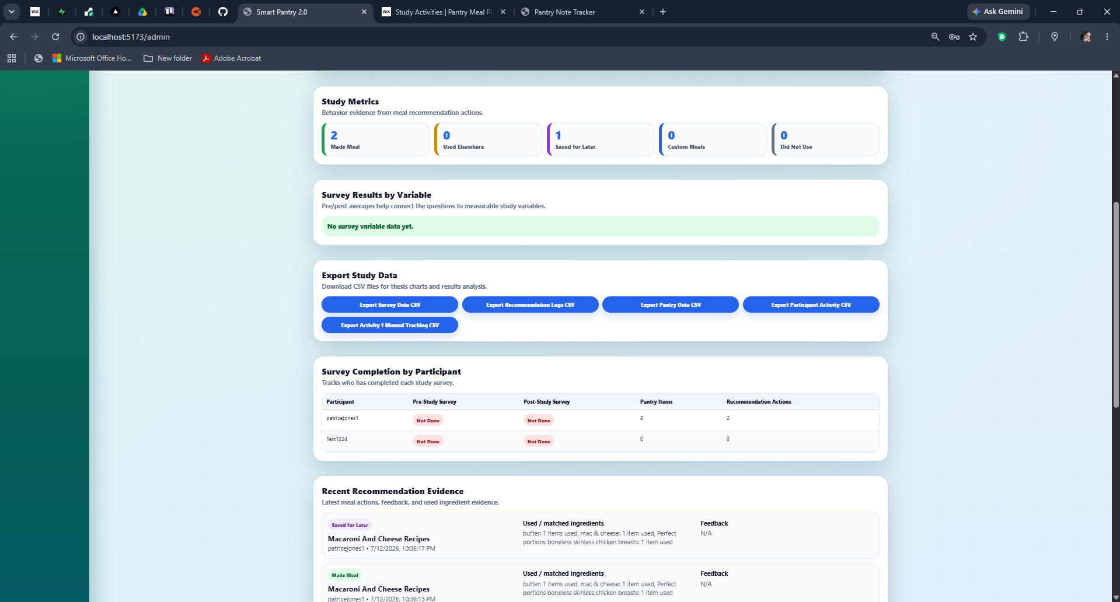
Figure 8. Administrator evidence and export interface.

4.6 Pilot Feedback and Iterative Improvement
The completed pilot led to several practical changes. Survey questions were moved to a neutral external workflow, loading messages were added to the recommendation page, recommendation categories were corrected, participant-facing language was simplified, login and support instructions were improved, mobile resizing issues were addressed, and the Smart Swap feature was changed to include suggested and participant-created substitutions. These revisions directly respond to advisor and participant feedback and demonstrate meaningful progress from the first thesis draft.

4.7 Current Status and Remaining Work
The current platform is deployed and ready for continued pilot refinement and full participant recruitment. Remaining work includes final testing of all study links, continued mobile checks, confirmation of external comparison instructions, monitoring of recommendation performance, and completion of the full participant study. Final statistical results will be added after the required sample has completed the study.

5. References
[1] U.S. Department of Agriculture, “Food Loss and Waste,” USDA. [Online]. Available: https://www.usda.gov/about-food/food-safety/food-loss-and-waste. [Accessed: May 1, 2026].
[2] U.S. Environmental Protection Agency, “United States 2030 Food Loss and Waste Reduction Goal,” EPA. [Online]. Available: https://www.epa.gov/sustainable-management-food/united-states-2030-food-loss-and-waste-reduction-goal. [Accessed: July 1, 2026].
[3] Samsung Food, “Samsung Food,” [Online]. Available: https://samsungfood.com/. [Accessed: May 1, 2026].
[4] SuperCook, “Recipe Search by Ingredients,” [Online]. Available: https://www.supercook.com/. [Accessed: May 1, 2026].
[5] K. J. P. Ortiz, P. N. P. Bautista, M. V. D. Dimailig, and A. C. D. Llamzon, “Recipe Recommendation System Using IoT-Based Food Inventory Management of Perishables for Household Food Waste Reduction,” Chemical Engineering Transactions, vol. 106, pp. 361-366, 2023, doi: 10.3303/CET23106061. [Accessed: Jun. 1, 2026].
[6] M. S. Rodrigues, J. F. Ribeiro, D. F. Pereira, and P. J. Cardoso, “RecipeIS-Recipe Recommendation System Based on Recognition of Food Ingredients,” Applied Sciences, vol. 13, no. 13, Art. no. 7880, 2023, doi: 10.3390/app13137880. [Accessed: Jun. 1, 2026].
[7] S. Chhipa, S. B. Dabre, and R. A. Chaudhari, “Recipe Recommendation System Using TF-IDF,” ITM Web of Conferences, vol. 44, Art. no. 02006, 2022, doi: 10.1051/itmconf/20224402006. [Accessed: Jun. 1, 2026].
[8] M. A. Chatti, M. Guesmi, and A. Muslim, “Visualization for Recommendation Explainability: A Survey and New Perspectives,” arXiv:2305.11755, 2023. [Accessed: Jun. 1, 2026].
[9] Y. Zhang and X. Chen, “Explainable Recommendation: A Survey and New Perspectives,” Foundations and Trends in Information Retrieval, vol. 14, no. 1, pp. 1-101, 2020, doi: 10.1561/1500000066. [Accessed: Jun. 1, 2026].
[10] scikit-learn Developers, “RandomForestRegressor,” scikit-learn Documentation. [Online]. Available: https://scikit-learn.org/stable/modules/generated/sklearn.ensemble.RandomForestRegressor.html. [Accessed: May 1, 2026].
[11] Open Food Facts, “Open Food Facts-World Food Database,” [Online]. Available: https://world.openfoodfacts.org/. [Accessed: Jun. 20, 2026].

